Task EC2 -08:

1 Launch one EC2 using Amazon Linux 2 image and add a script in user data to install Apache.

. Objective
To launch an AWS EC2 instance using an Amazon Linux 2 (AL2) Amazon Machine Image (AMI) and leverage the User Data bootstrap execution field to automatically update the system, install the Apache HTTP server, and publish a dynamic web landing page without manual terminal intervention.
2. Implementation Steps
Step 1: Initialize Instance Parameters
- Action: Navigated to the EC2 Dashboard and initialized the Launch Instance wizard.
- AMI Selection: Selected the Amazon Linux 2 AMI (HVM) from the Quick Start repository list.
- Hardware Sizing: Allocated a Free-Tier eligible t2.micro compute shape.
Step 2: Firewall & Network Rules Configuration
- Action: Configured a new network security group to handle incoming external connections.
- Rule 1 (SSH): Enabled TCP Port 22 sourced from Anywhere (0.0.0.0/0) to allow secure remote command-line access.
- Rule 2 (HTTP): Checked the box Allow HTTP traffic from the internet to automatically map a rule for TCP Port 80 sourced from Anywhere (0.0.0.0/0).

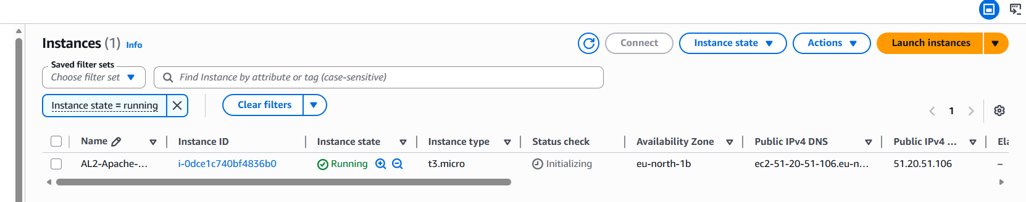

Step 3: Injecting the User Data Bootstrap Script
- Action: Expanded the Advanced Details toggle tab at the bottom of the provisioning page, scrolled down to the plain-text User data input block, and pasted the automated configuration script.
- Crucial Setting: Left the checkbox option "User data has already been base64 encoded" unchecked to ensure the AWS control layer natively handled script parsing.
Script:
#!/bin/bash
# 1. Upgrade the native system package mirrors
yum update -y

# 2. Install the Apache HTTP Server framework binaries
yum install httpd -y

# 3. Initialize the background service daemon process
systemctl start httpd

# 4. Configure Apache to launch automatically on every hardware boot cycle
systemctl enable httpd

# 5. Fetch the unique instance ID dynamically from AWS IMDSv1 Metadata layers
INSTANCE_ID=$(curl -s http://169.254.169.254/latest/meta-data/instance-id)

# 6. Deploy the customized, automated HTML landing page to the web directory root
echo "<h1>Welcome to Apache on Amazon Linux 2!</h1><p>Instance ID: $INSTANCE_ID</p>" > /var/www/html/index.html

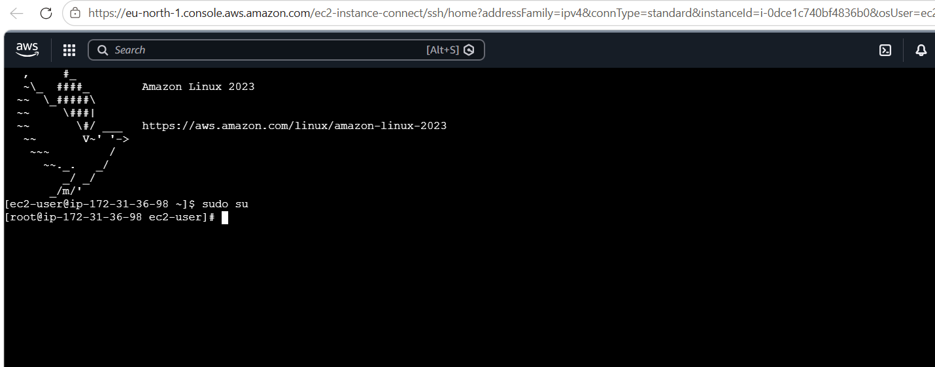

Technical Explanation of cloud-init Architecture
When an EC2 instance passes its hardware initialization phase, a built-in multi-distribution cloud initialization utility called cloud-init wakes up. It reaches out to the internal AWS Metadata service link (http://169.254.169.254) to fetch any raw initialization strings stored in the instance profile.
Because our script starts with a shebang (#!/bin/bash), the cloud-init utility recognizes it as an executable shell sequence. It automatically elevates its execution state to the root administrative user level, runs through the commands sequentially before the login prompt is ever generated, and saves hours of repetitive deployment work. This deployment pattern forms the core foundation of DevOps Infrastructure as Code (IaC) pipelines.
5. Verification Verification Checklist
To prove successful automated deployment, verify the following milestones inside your document:
- [ ] Instance State: Public instance state switches to a green Running status inside the EC2 console dashboard.
- [ ] Status Checks: System passes the native 2/2 status checks verification metrics.
- [ ] Live Browser Access: Navigating directly to http://<your-ec2-public-ip-address> successfully renders the custom index landing page showing your unique instance ID without hitting a network timeout wall.

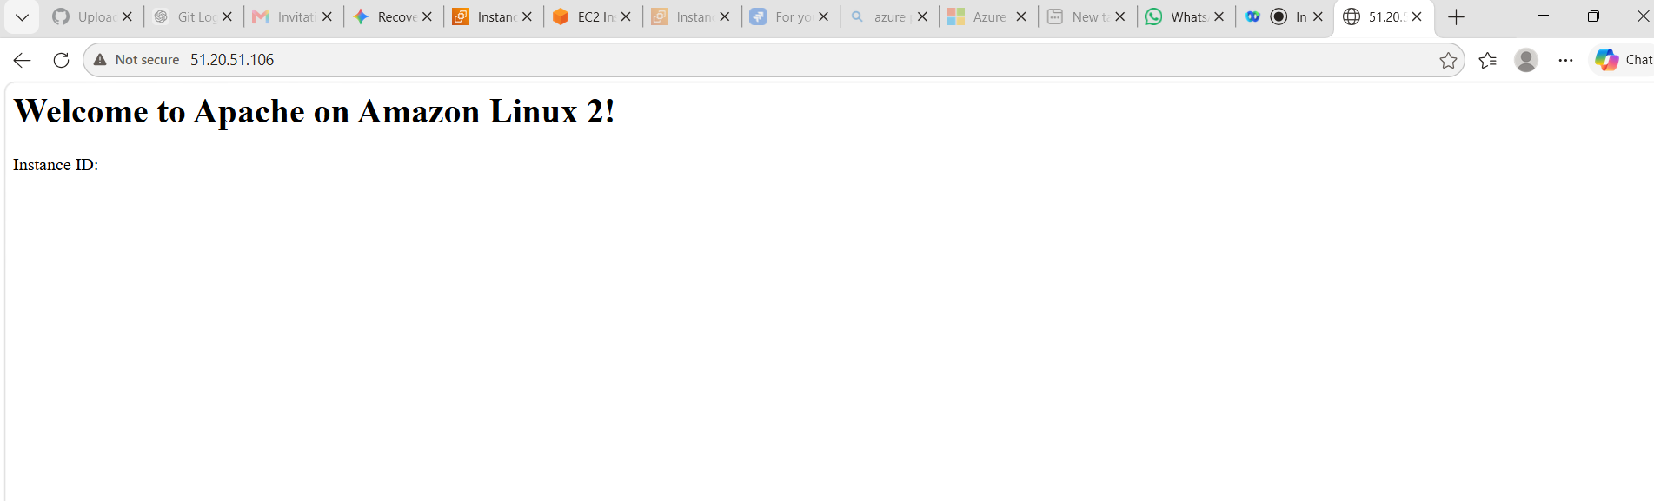

Result: Apache on Amazon Llinux working properly

2. Launch one EC2 using Ubuntu image and add a script in user data to install Nginx.

### 1. Objective
To deploy an AWS EC2 instance using a native Ubuntu Server LTS image and utilize the cloud-init User Data subsystem to automatically bootstrap an unencrypted Nginx web server gateway on standard HTTP Port 80.

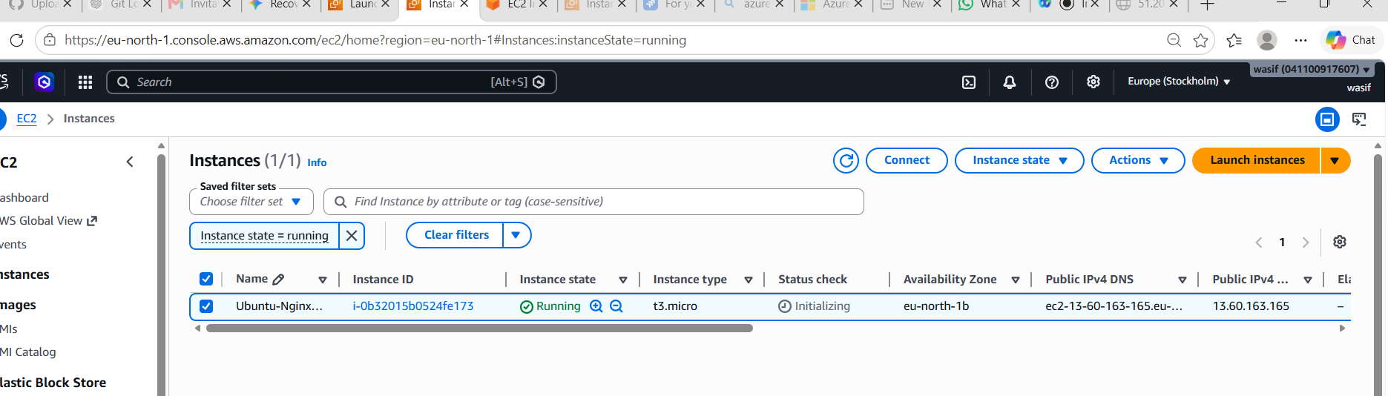

### 2. Implementation Flow
* Operating System Baseline: Ubuntu Server LTS (Debian-based architecture)
* Firewall Rule Base: Inbound Security Group modified to open TCP Port 22 (SSH) and TCP Port 80 (HTTP) to public traffic tracking (0.0.0.0/0).
* Provisioning Method: Automated shell injection via pre-boot User Data container execution.

### 3. Automated Script Reference
#!/bin/bash
apt-get update -y
apt-get install nginx -y
systemctl start nginx
systemctl enable nginx
INSTANCE_ID=$(curl -s http://169.254.169.254/latest/meta-data/instance-id)
echo "<h1>Welcome to Nginx on Ubuntu!</h1><p>Instance ID: $INSTANCE_ID</p>" > /var/www/html/index.nginx-debian.html
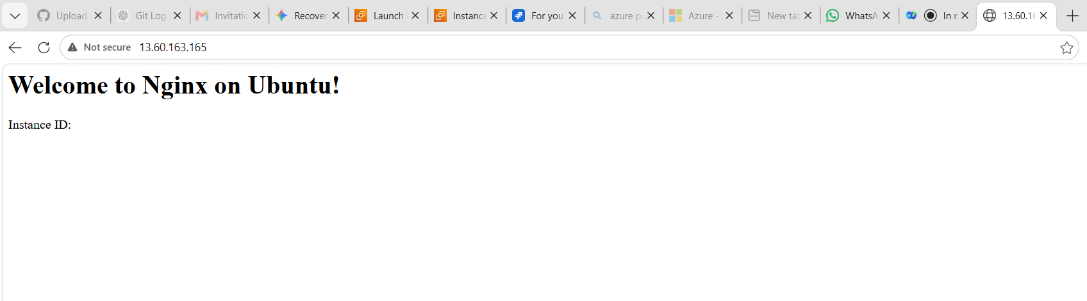

Technical Takeaways & Architecture Distinctions
1. Package Manager Divergence: Unlike RedHat-based environments (Amazon Linux/CentOS) which utilize 'yum' or 'dnf' package trees, Ubuntu utilizes the Advanced Package Tool ('apt-get') utility framework to fetch application binaries.
2. Target Directory Mapping: The default landing page index mapping for Nginx on standard Ubuntu distributions points explicitly to '/var/www/html/index.nginx-debian.html' instead of the standard RedHat Apache web root location ('/var/www/html/index.html').
3. Automated Bootstrapping: Leveraging cloud-init allows standard OS environments to achieve immediate production readiness on first-boot, establishing a solid foundation for programmatic immutable infrastructure deployment.

3. Launch one Windows server and install Tomcat on Windows.

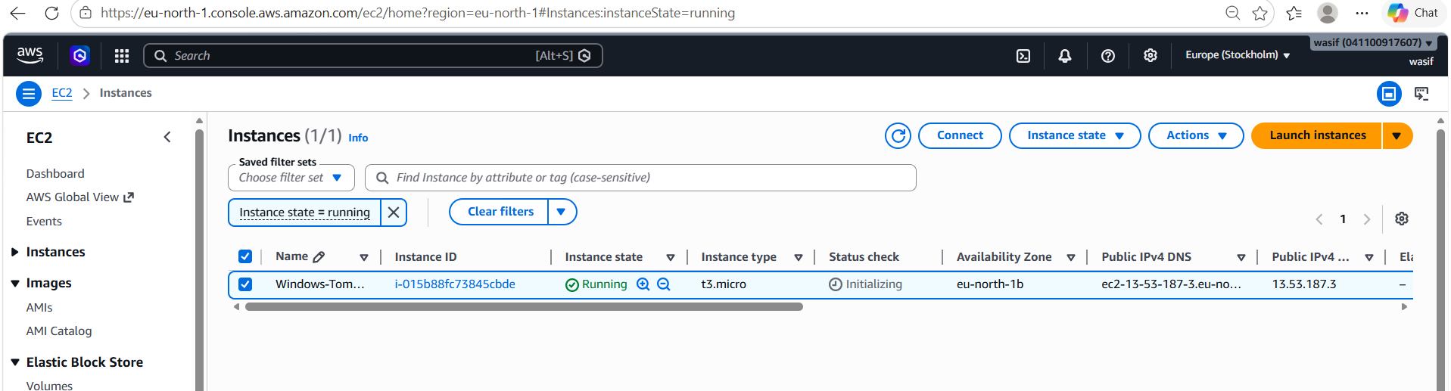

Phase 1: Local Terminal (AWS CLI Setup & Password Extraction)
Step 1: Run the Password Command
Open Git Bash on your personal laptop, make sure you are in the directory containing your Linux-learning.pem file, and execute this command to display your server password:
Bash
aws ec2 get-password-data \
--instance-id i-015b88fc73845cbde \
--priv-launch-key Linux-learning.pem \
--region eu-north-1 \
--query "PasswordData" \
--output text
- Expected Output: A string of characters like (5p);vX8UgGCeIHbrYVYZ=foTfok4@Dc. Copy this string exactly.
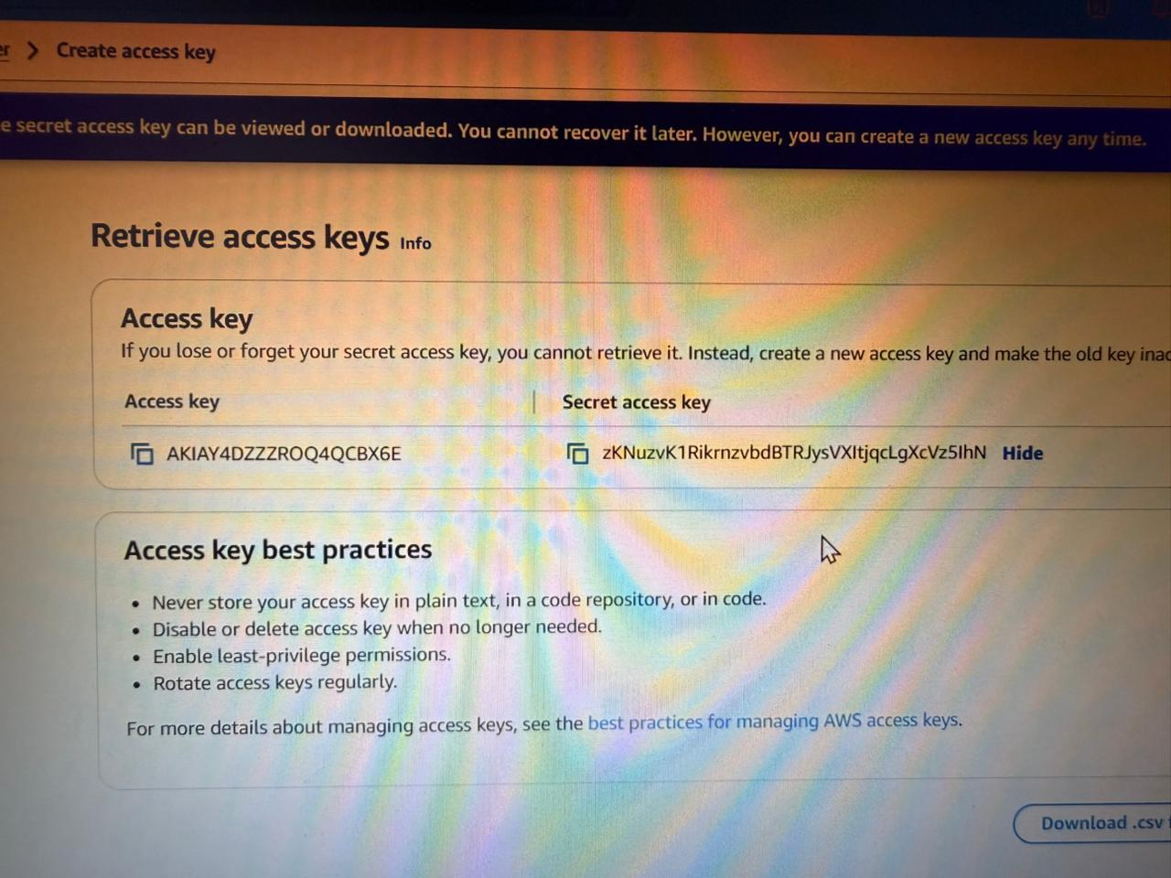
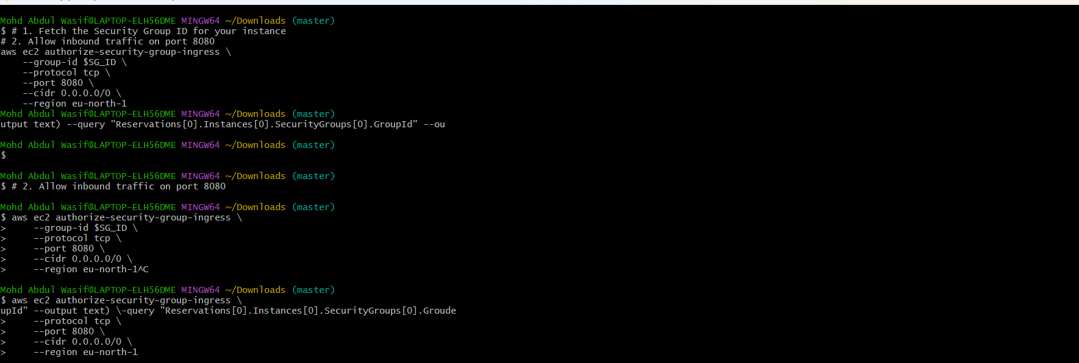

Phase 2: Remote Desktop (RDP) Login
Step 2: Configure the Remote Desktop Client
- Press the Windows Key on your laptop, search for Remote Desktop Connection, and open it.
- In the Computer field, paste your instance's Public IP: 51.21.193.85
- Click Connect.
Step 3: Enter Credentials
- When the Windows Security prompt appears, click More choices -> Use a different account.
- For the username, type exactly:
Plaintext
.\Administrator
- In the password field, paste the text you extracted in Step 1.
- Click OK. If a warning pop-up appears regarding an untrusted certificate, click Yes to proceed
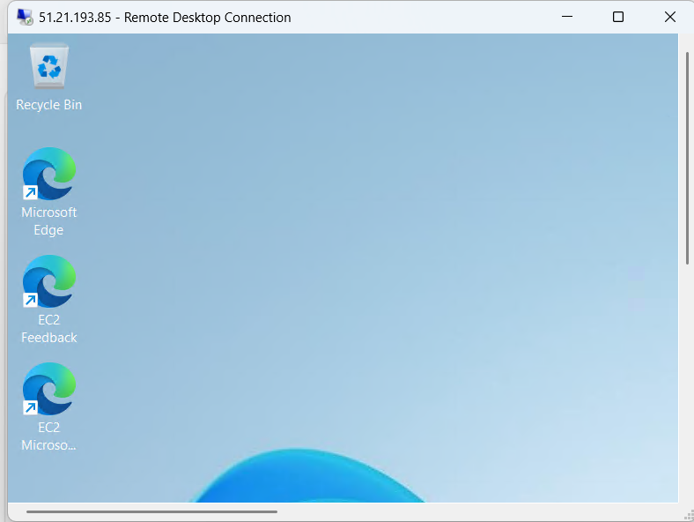

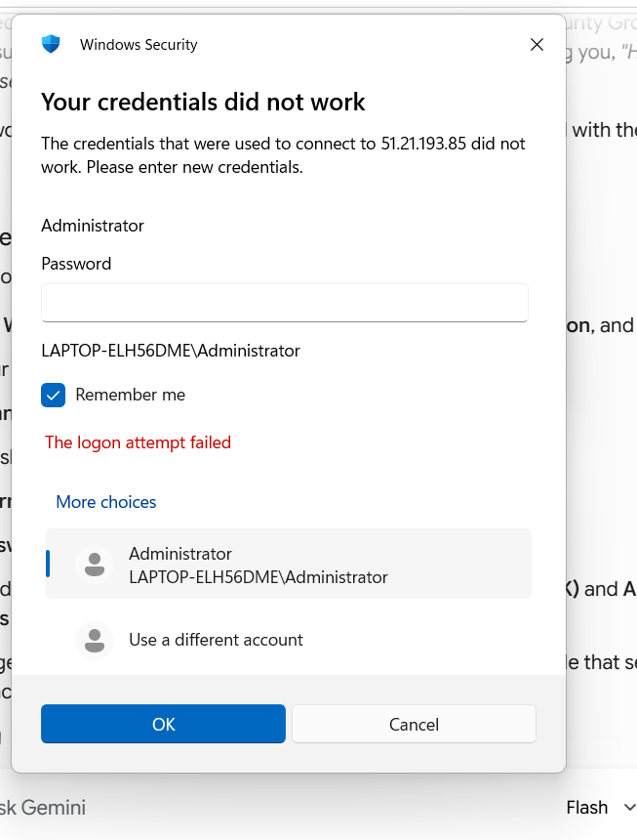

Phase 3: Inside the Windows Server (Software Installation)
Once your remote desktop environment loads, execute these steps inside that screen:
Step 4: Install Java (JDK 17)
- Open Microsoft Edge inside the remote desktop.
- Go to the Adoptium Eclipse Temurin Downloads page and download the Windows x64 .msi installer for Java 17.
- Run the installer. On the customization step, click the red X dropdown next to Set JAVA_HOME variable and change it to "Will be installed on local hard drive".
- Complete the installation wizard.
Step 5: Install Apache Tomcat
- Inside the server's browser, head over to tomcat.apache.org and click Tomcat 10 from the left navigation pane.
- Under the Core list, download the 32-bit/64-bit Windows Service Installer (.exe).
- Run the setup file. When you reach the Configuration page, create an administrative username and password (you'll use this to log into the Tomcat web control panel later).
- Click through the remaining default setup steps (it will auto-detect your Java installation path) and click Install.
- On the final page, leave Run Apache Tomcat selected and click Finish.
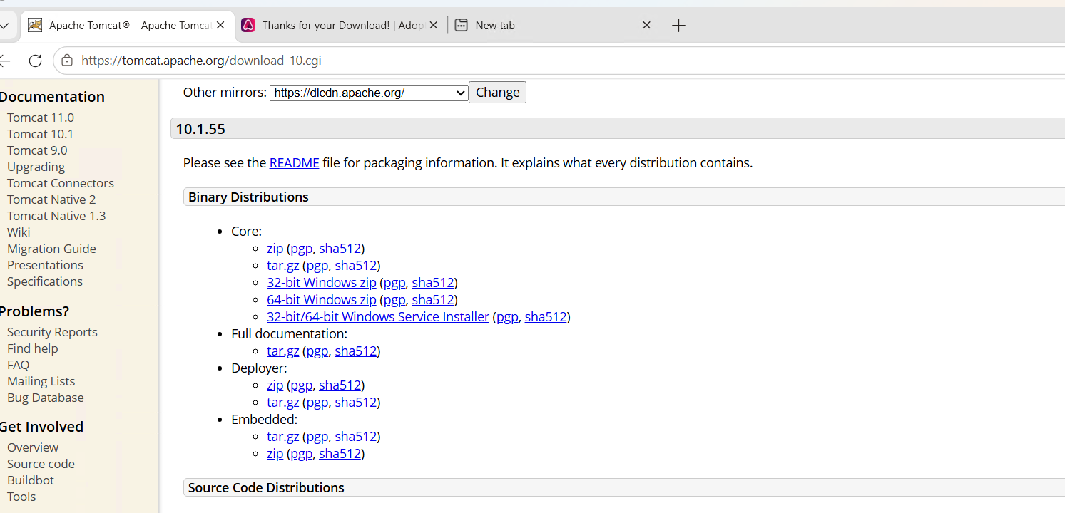

Phase 4: Inside the Windows Server (Local Firewall Rule)
Step 6: Allow Port 8080 Through Windows Firewall
- Click the Windows Start menu inside the server, type Windows Defender Firewall with Advanced Security, and open it.
- Select Inbound Rules on the left menu pane.
- Click New Rule... on the right actions pane.
- Choose Port and hit Next.
- Choose TCP, specify local port 8080, and click Next.
- Select Allow the connection and click Next.
- Keep Domain, Private, and Public selected, then click Next.
- Name your rule Tomcat and click Finish

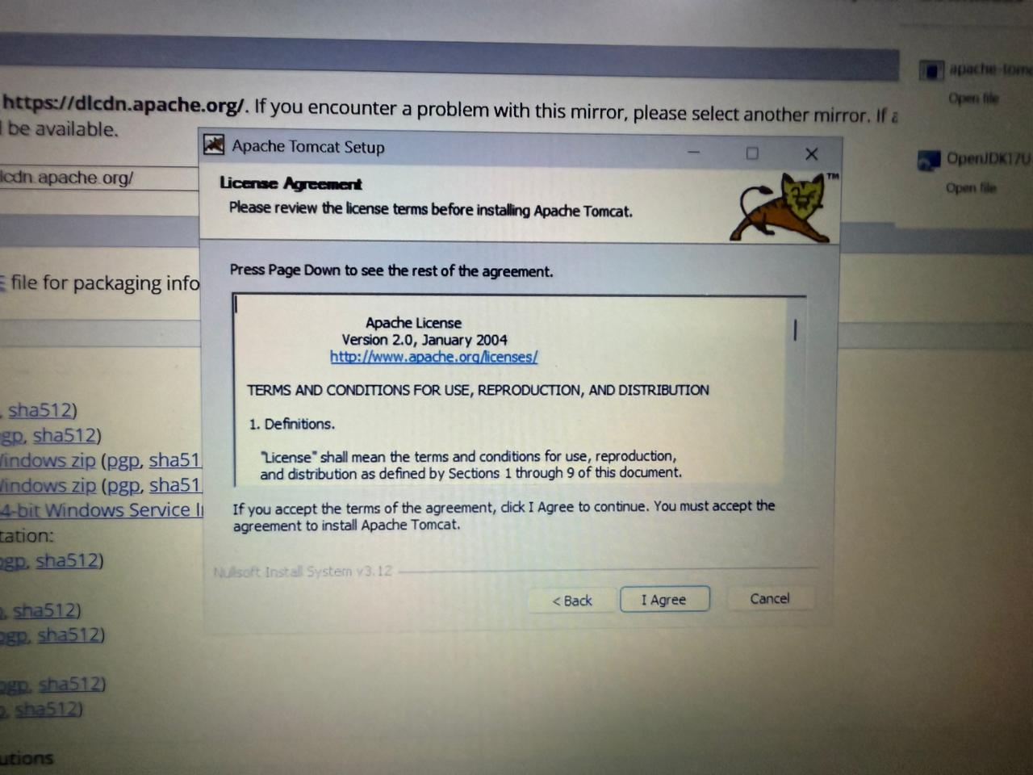
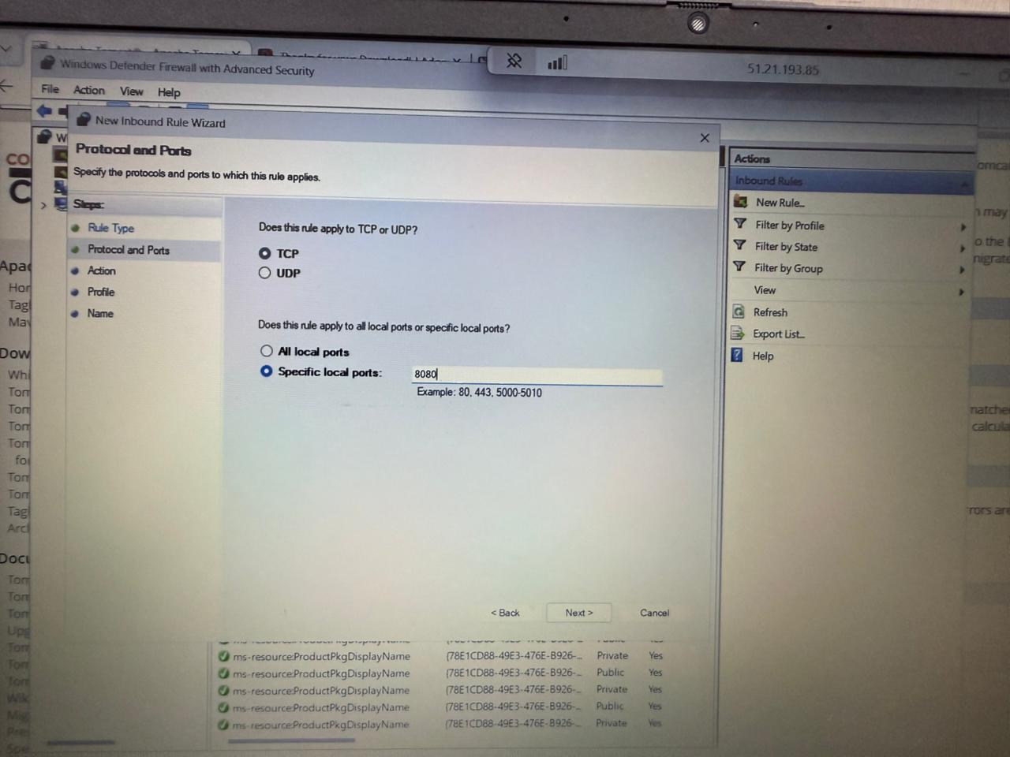
Phase 5: Verification
Step 7: Access From Your Personal Laptop
Minimize your Remote Desktop window. Open your regular browser window on your personal computer and head to:
Plaintext
http://51.21.193.85:8080

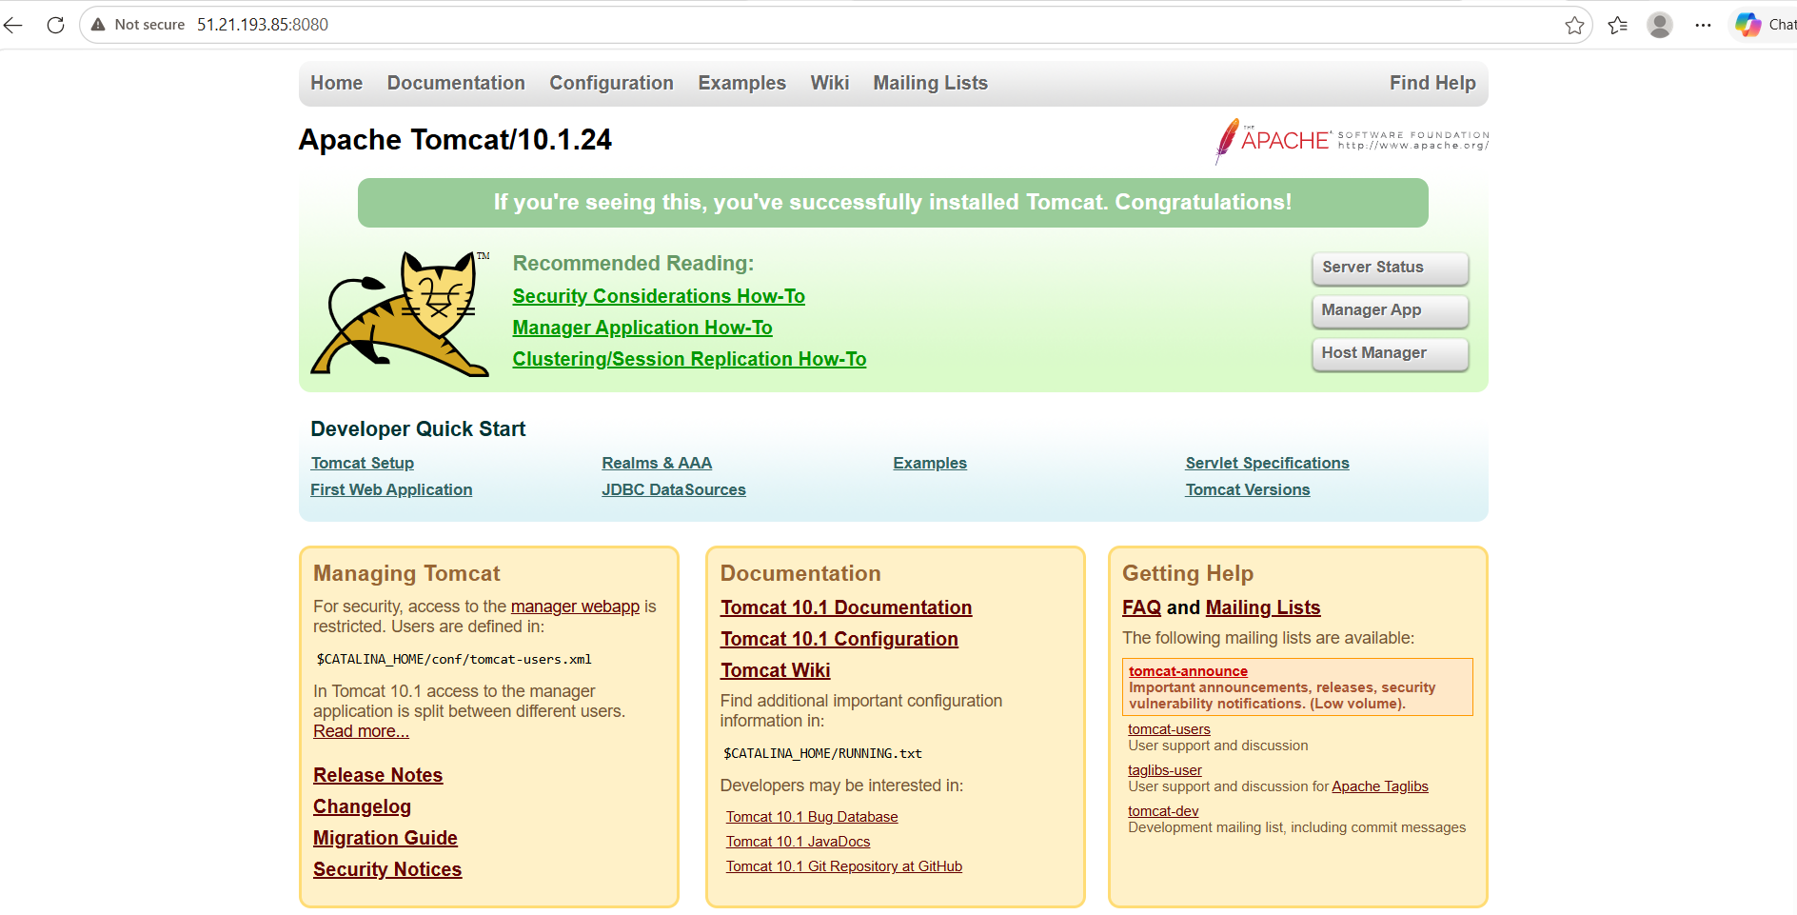

4.Take a snapshot of the instance created in Task 1.

Navigate to Instances: Open the AWS EC2 Management Console and locate your running Windows-Tomcat-App Server instance.
Access Storage Details: Click on the instance, scroll down to the properties pane, and select the Storage tab.
Isolate Volume Resource: Locate the unique root disk block identifier string under the Volume ID column.
Pivot to Volumes Ledger: Click the hyperlinked Volume ID to jump directly into the Elastic Block Store (EBS) dashboard.
Initialize Snapshot

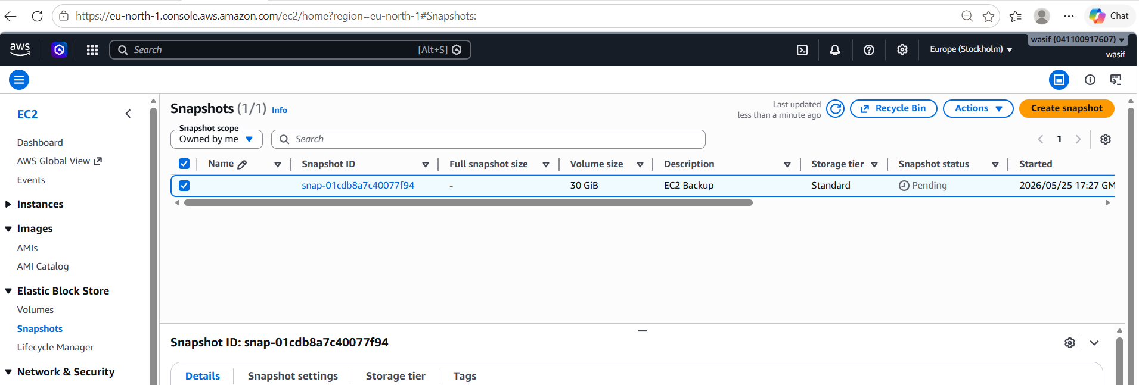

- What You Did Practically
Logged into AWS console
- Opened EC2 instance
- Selected attached EBS volume
- Created a snapshot
- Verified snapshot in AWS dashboard

Why Snapshot is Important
✔ Backup data
✔ Recover deleted files
✔ Restore server anytime
✔ Create new servers from backup
✔ Used in real DevOps production systems

5.Assign passwordless authentication for the EC2 created in Task 2.
Steps:

- Login to AWS EC2 Console and open the instance created in Task 2
- Copy the Public IPv4 address of the EC2 instance
- Open Git Bash/Terminal on local system (not inside EC2)
- Go to the location of the .pem key file and set permission using chmod 400 key.pem
- Run SSH command: ssh -i key.pem ubuntu@<public-ip>
- Type “yes” when asked for confirmation to establish connection
- Successful login without password confirms passwordless authentication is enabled
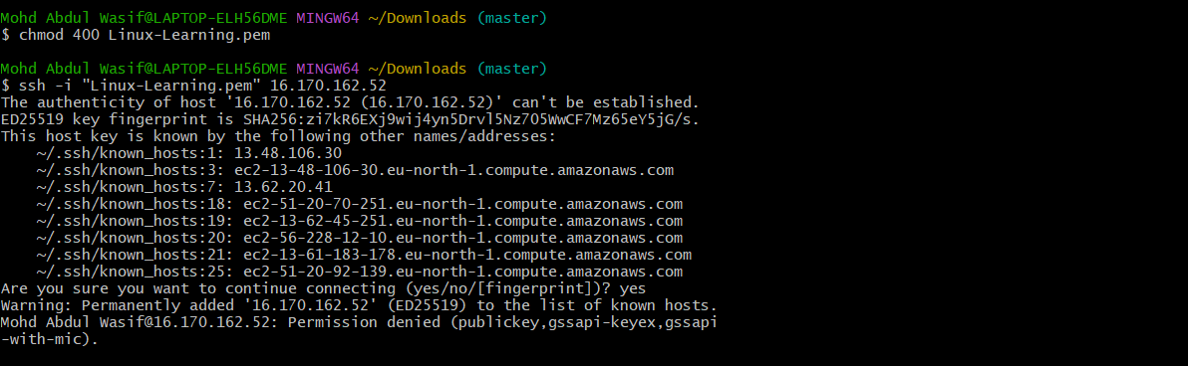

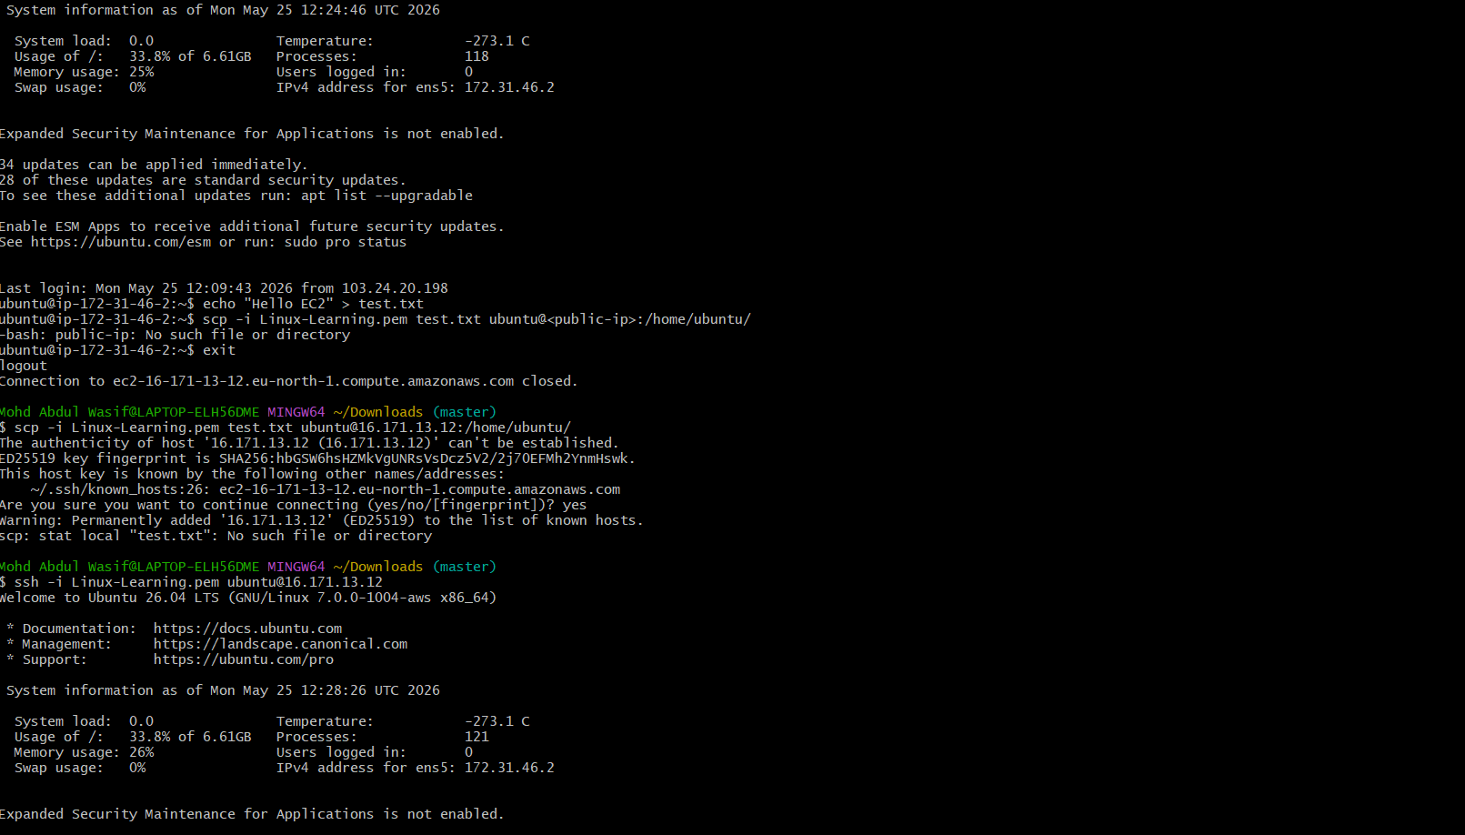

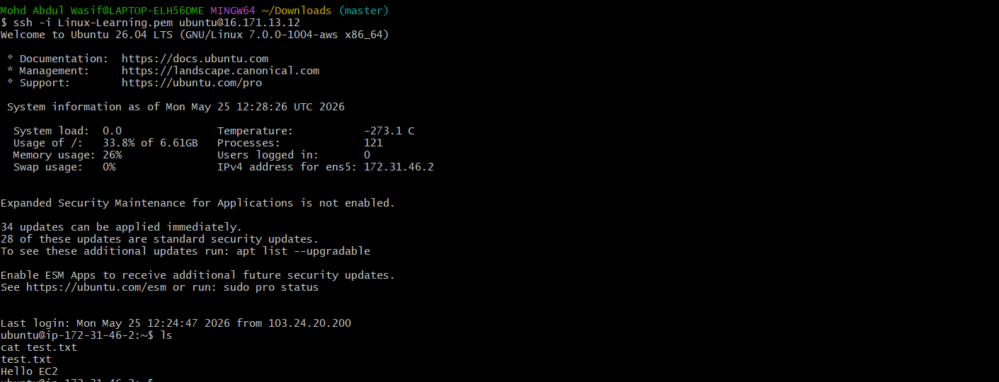

Result
Passwordless authentication is successfully configured using SSH key pair, where:
- Private key stays on local system
- Public key is stored in EC2 instance
- Login is done without password

6. Launch any EC2 using the spot purchasing option.

Steps:
- Login to AWS Management Console and open EC2 service
- Click on “Launch Instance” and choose an Amazon Machine Image (AMI)
- Select an instance type (example: t2.micro or t3.micro)
- In “Purchase options”, select “Request Spot Instances”
- Configure key pair, security group, and storage as required
- Click “Launch Instance” to create the Spot EC2 instance
- Verify the instance state in EC2 dashboard (Spot instance will be running if capacity is available)
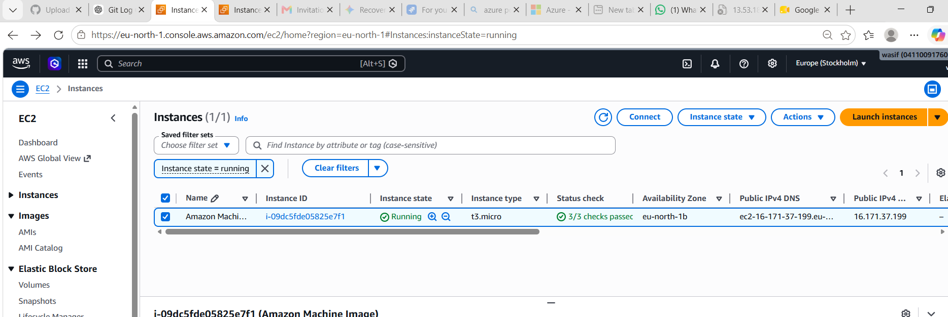

Result
A Spot EC2 instance is successfully launched at a lower cost compared to on-demand instances.

7.Enable termination policy on the EC2 created in Task 2.

Step 1
Login to Amazon Web Services Management Console.

🔹 Step 2
Go to EC2 Dashboard → Instances.

🔹 Step 3
Select the EC2 instance created in Task 2.
Step 4
Click Actions → Instance settings.

🔹 Step 5
Select Change termination protection.

🔹 Step 6
Click Enable termination protection.

🔹 Step 7
Click Save / Apply changes.

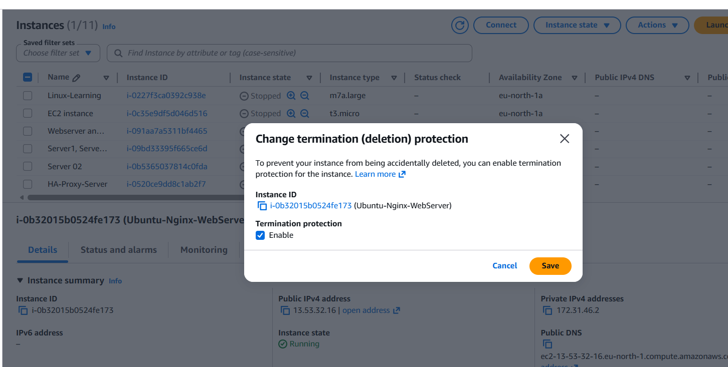

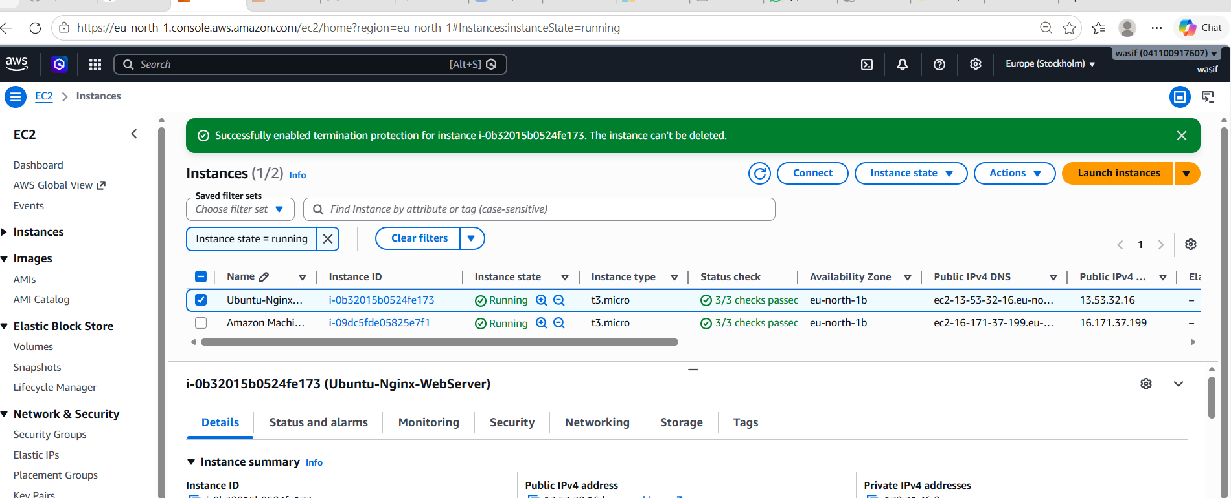
Final Result
✔ Termination protection enabled successfully
✔ Your EC2 instance is now safe from accidental deletion
✔ Task completed correctly 👍

8. Launch one EC2 using AWS CLI.
Steps:
Opened CMD and Navigated to Folder
- Handled your terminal location (cd %USERPROFILE%\Downloads) so your system could find your security keys.
Created Fresh AWS Access Keys
- Generated a brand-new set of credentials in the AWS Web Console because the old secret key was lost.
Downloaded the Credentials File
- Saved the .csv key file immediately to your laptop before closing the AWS window so it wouldn't be hidden forever.
Configured the AWS CLI
- Ran aws configure in CMD to log into your account using your new Access Key and Secret Key.
Checked for Existing Cloud Key Pairs
- Ran aws ec2 describe-key-pairs to list the exact names of security keys registered in your region.
Fixed Case-Sensitivity Typos
- Discovered that AWS requires perfect matching, changing the key name from lowercase linux-learning to the correct uppercase Linux-Learning.
Launched the EC2 Instance
- Ran the aws ec2 run-instances command to create your new Amazon Linux 2023 server.
Verified the Server State and IP
- Ran aws ec2 describe-instances to confirm your server successfully changed to "running" and retrieved its unique Public IP.

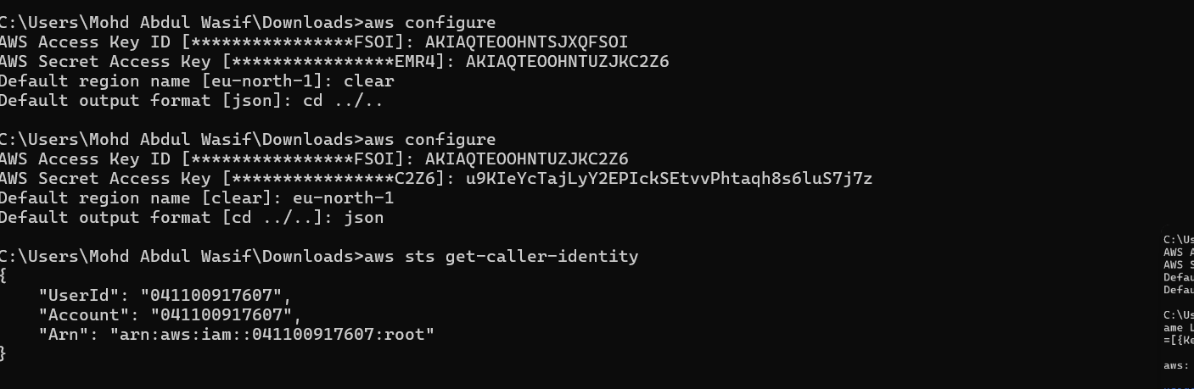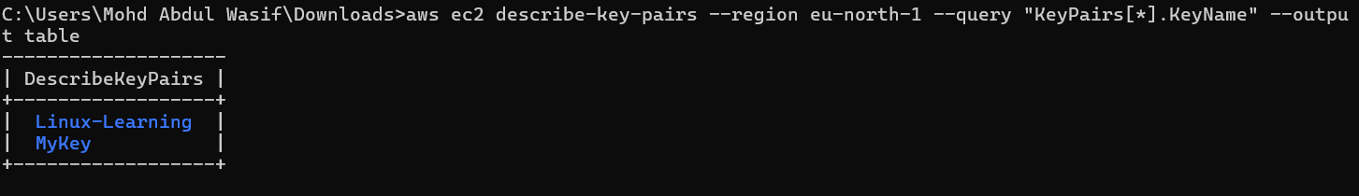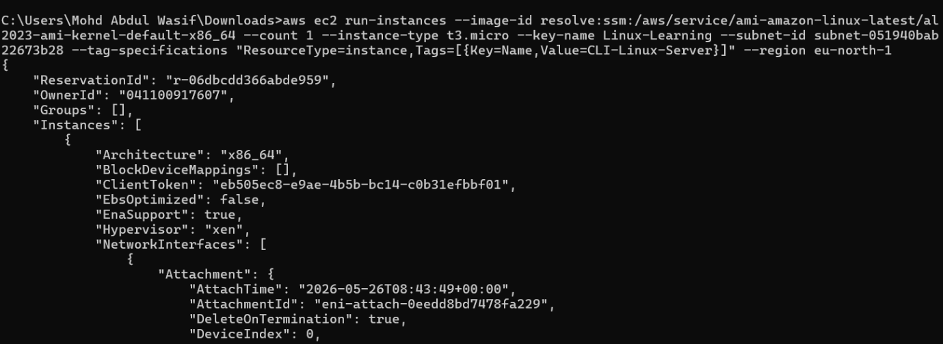
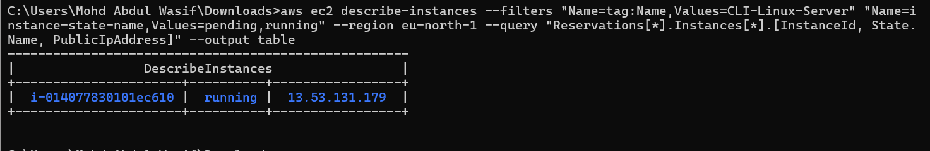

What You Learnt From This
- Capitalization Matters: AWS is strictly case-sensitive. A single wrong capital letter will cause an error.
- Save Secrets Instantly: You only get one chance to download or view your Secret Access Key.
- Direct IDs Are Safer: Relying on explicit IDs (like your specific subnet) makes your terminal commands reliable across different command windows.

